**Assignment 1**

**Name**:Bhavin Patil

**Roll No:** 66

**TY-CS-D**

Implementation of simple DES algorithm with output

**Simplified Data Encryption Standard**

**Introduction**

* Simplified Data Encryption Standard is a simple version of [Data Encryption Standard](https://www.geeksforgeeks.org/data-encryption-standard-des-set-1/) having a 10-bit key and 8-bit plain text.
* It is much smaller than the DES algorithm as it takes only 8-bit plain text whereas DES takes 64-bit plain text.
* It was developed for educational purpose so that understanding DES can become easy.
* It is a block cipher algorithm and uses a symmetric key for its algorithm i.e. they use the same key for both encryption and decryption.
* It has 2 rounds for encryption which use two different keys.
* First, we need to generate 2 keys before encryption. After generating keys we pass them to each individual round for s-des encryption.

**Components**

S-DES encryption involves four functions –

**1. Initial permutation(IP) –**

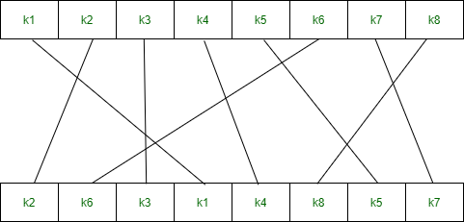

**2. Complex function (fk) –** It is the combination of permutation and substitution functions. The below image represents a round of encryption and decryption. This round is repeated twice in each encryption and decryption. 

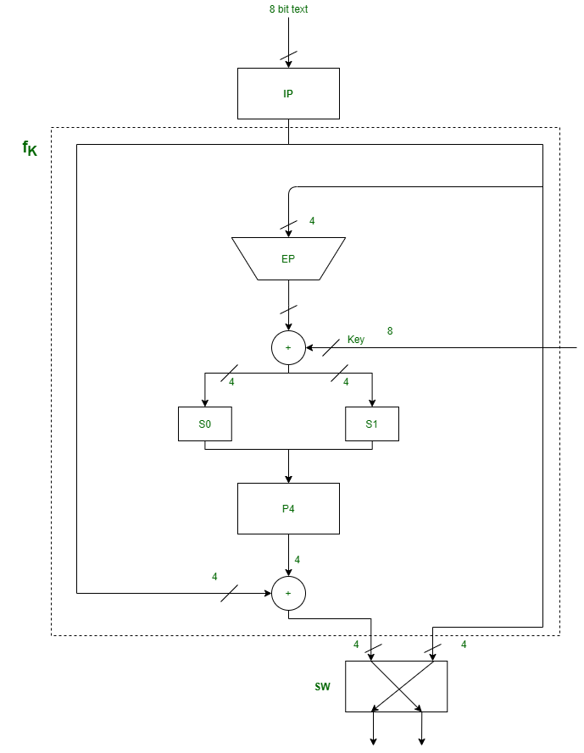

Components in fk are –

**a. Expanded Permutation (EP) –**It takes a 4-bit input and converts it into an 8-bit output.

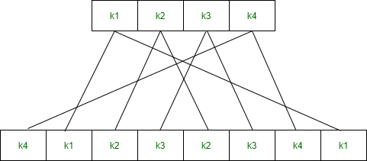

**b. S-boxes (S0 and S1) –** It is a basic component of a symmetric key algorithm that performs substitution.

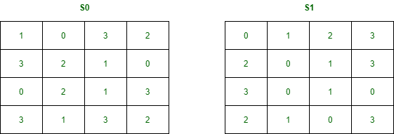

**c. Permutation P4 –**

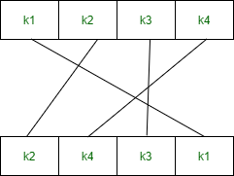

**3. Switch (SW) –**

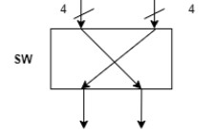

**4. Inverse of Initial Permutation (IP-1) –**

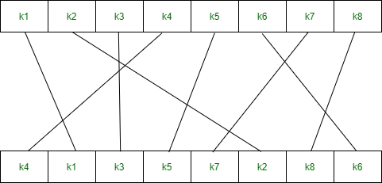

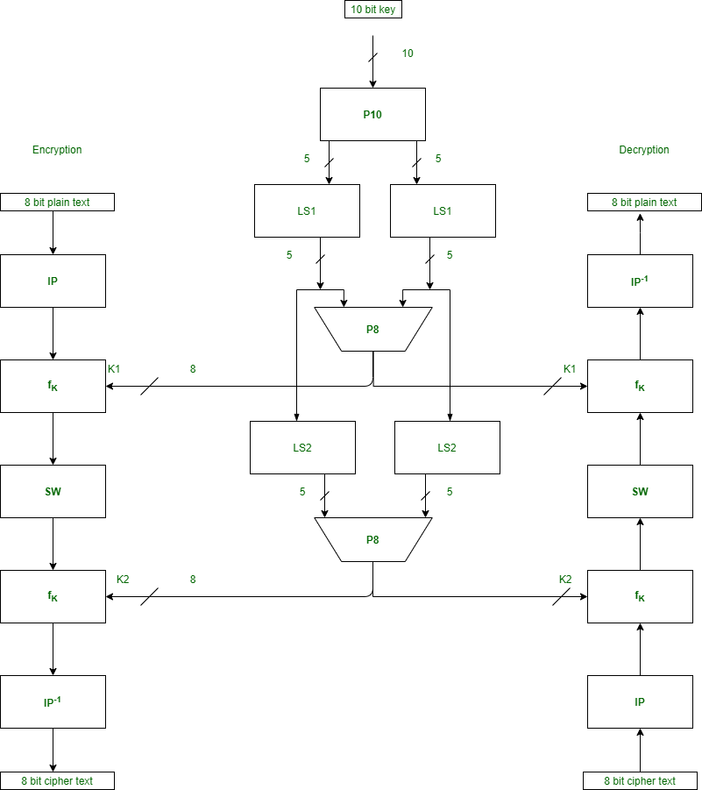**Flowchart**

**Code**

package sdes;

import java.io.*;

public class SDES {

int key[] = {

1, 0, 1, 0, 0, 0, 0, 0, 1, 0

};

int P10[] = { 3, 5, 2, 7, 4, 10, 1, 9, 8, 6 };

int P8[] = { 6, 3, 7, 4, 8, 5, 10, 9 };

int key1[] = new int[8];

int key2[] = new int[8];

int[] IP = { 2, 6, 3, 1, 4, 8, 5, 7 };

int[] EP = { 4, 1, 2, 3, 2, 3, 4, 1 };

int[] P4 = { 2, 4, 3, 1 };

int[] IP_inv = { 4, 1, 3, 5, 7, 2, 8, 6 };

int[][] S0 = { { 1, 0, 3, 2 },

{ 3, 2, 1, 0 },

{ 0, 2, 1, 3 },

{ 3, 1, 3, 2 } };

int[][] S1 = { { 0, 1, 2, 3 },

{ 2, 0, 1, 3 },

{ 3, 0, 1, 0 },

{ 2, 1, 0, 3 } };

void key_generation()

{

int key_[] = new int[10];

for (int i = 0; i < 10; i++) {

key_[i] = key[P10[i] - 1];

}

int Ls[] = new int[5];

int Rs[] = new int[5];

for (int i = 0; i < 5; i++) {

Ls[i] = key_[i];

Rs[i] = key_[i + 5];

}

int[] Ls_1 = shift(Ls, 1);

int[] Rs_1 = shift(Rs, 1);

for (int i = 0; i < 5; i++) {

key_[i] = Ls_1[i];

key_[i + 5] = Rs_1[i];

}

for (int i = 0; i < 8; i++) {

key1[i] = key_[P8[i] - 1];

}

int[] Ls_2 = shift(Ls, 2);

int[] Rs_2 = shift(Rs, 2);

for (int i = 0; i < 5; i++) {

key_[i] = Ls_2[i];

key_[i + 5] = Rs_2[i];

}

for (int i = 0; i < 8; i++) {

key2[i] = key_[P8[i] - 1];

}

System.out.println("\nKey-1 :");

for (int i = 0; i < 8; i++)

System.out.print(key1[i] + " ");

System.out.println();

System.out.println("\nKey-2 :");

for (int i = 0; i < 8; i++)

System.out.print(key2[i] + " ");

}

int[] shift(int[] ar, int n)

{

while (n > 0) {

int temp = ar[0];

for (int i = 0; i < ar.length - 1; i++) {

ar[i] = ar[i + 1];

}

ar[ar.length - 1] = temp;

n--;

}

return ar;

}

int[] encryption(int[] plaintext)

{

int[] arr = new int[8];

for (int i = 0; i < 8; i++) {

arr[i] = plaintext[IP[i] - 1];

}

int[] arr1 = function_(arr, key1);

int[] after_swap = swap(arr1, arr1.length / 2);

int[] arr2 = function_(after_swap, key2);

int[] ciphertext = new int[8];

for (int i = 0; i < 8; i++) {

ciphertext[i] = arr2[IP_inv[i] - 1];

}

return ciphertext;

}

String binary_(int val)

{

if (val == 0)

return "00";

else if (val == 1)

return "01";

else if (val == 2)

return "10";

else

return "11";

}

int[] function_(int[] ar, int[] key_)

{

int[] l = new int[4];

int[] r = new int[4];

for (int i = 0; i < 4; i++) {

l[i] = ar[i];

r[i] = ar[i + 4];

}

int[] ep = new int[8];

for (int i = 0; i < 8; i++) {

ep[i] = r[EP[i] - 1];

}

for (int i = 0; i < 8; i++) {

ar[i] = key_[i] ^ ep[i];

}

int[] l_1 = new int[4];

int[] r_1 = new int[4];

for (int i = 0; i < 4; i++) {

l_1[i] = ar[i];

r_1[i] = ar[i + 4];

}

int row, col, val;

row = Integer.parseInt("" + l_1[0] + l_1[3], 2);

col = Integer.parseInt("" + l_1[1] + l_1[2], 2);

val = S0[row][col];

String str_l = binary_(val);

row = Integer.parseInt("" + r_1[0] + r_1[3], 2);

col = Integer.parseInt("" + r_1[1] + r_1[2], 2);

val = S1[row][col];

String str_r = binary_(val);

int[] r_ = new int[4];

for (int i = 0; i < 2; i++) {

char c1 = str_l.charAt(i);

char c2 = str_r.charAt(i);

r_[i] = Character.getNumericValue(c1);

r_[i + 2] = Character.getNumericValue(c2);

}

int[] r_p4 = new int[4];

for (int i = 0; i < 4; i++) {

r_p4[i] = r_[P4[i] - 1];

}

for (int i = 0; i < 4; i++) {

l[i] = l[i] ^ r_p4[i];

}

int[] output = new int[8];

for (int i = 0; i < 4; i++) {

output[i] = l[i];

output[i + 4] = r[i];

}

return output;

}

int[] swap(int[] array, int n)

{

int[] l = new int[n];

int[] r = new int[n];

for (int i = 0; i < n; i++) {

l[i] = array[i];

r[i] = array[i + n];

}

int[] output = new int[2 * n];

for (int i = 0; i < n; i++) {

output[i] = r[i];

output[i + n] = l[i];

}

return output;

}

int[] decryption(int[] ar)

{

int[] arr = new int[8];

for (int i = 0; i < 8; i++) {

arr[i] = ar[IP[i] - 1];

}

int[] arr1 = function_(arr, key2);

int[] after_swap = swap(arr1, arr1.length / 2);

int[] arr2 = function_(after_swap, key1);

int[] decrypted = new int[8];

for (int i = 0; i < 8; i++) {

decrypted[i] = arr2[IP_inv[i] - 1];

}

return decrypted;

}

public static void main(String[] args)

{

SDES obj = new SDES();

obj.key_generation();

int[] plaintext = {

1, 0, 0, 1, 0, 1, 1, 1

};

System.out.println();

System.out.println("\nPlain Text is :");

for (int i = 0; i < 8; i++)

System.out.print(plaintext[i] + " ");

int[] ciphertext = obj.encryption(plaintext);

System.out.println();

System.out.println("\nCipher Text is :");

for (int i = 0; i < 8; i++)

System.out.print(ciphertext[i] + " ");

int[] decrypted = obj.decryption(ciphertext);

System.out.println();

System.out.println("\nDecrypted Text is :");

for (int i = 0; i < 8; i++)

System.out.print(decrypted[i] + " ");

}

}

**Output**

